**LCD (Liquid Crystal Display)**

It is a type of flat-panel display

It uses liquid crystals between two sheets of material to present information on a screen

The LCD monitor creates images with a special kind of liquid crystal that is normally transparent but becomes opaque when charged with electricity.

As electric current passes through the liquid crystals, they twist

Depending on how much they twist, some light waves are passed through while other light waves are blocked. This creates the variety of color that appears on the screen

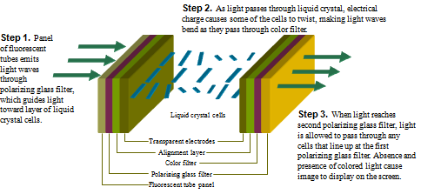

LCD monitors produce color using either passive-matrix or active-matrix technology

**Active Matrix LCD**

The active matrix LCD technology , also known as a TFT (thin-film transistor) display, **assigns a transistor to each pixel (or** to each liquid crystal cell**)**, and each pixel is turned on and off individually.

This enhancement allows the pixels to be refreshed much more rapidly and display is of high-quality color that is viewable from all angles (wider viewing angle)

Active matrix displays use **thin-film transistor** (TFT) technology, which employs as many as four transistors per pixel.

**Passive Matrix Display**

The passive matrix LCD relies on transistors for each row and each column of pixels, thus creating a grid that defines the location of each pixel. The color displayed by a pixel is determined by the electricity coming from the transistors

The passive matrix LCD relies on transistors for each row and each column of pixels, thus creating a grid that defines the location of each pixel. The color displayed by a pixel is determined by the electricity coming from the transistors

Passive-matrix display uses fewer transistors and requires less power than an active-matrix display

The color on a passive-matrix display often is not as bright as an active-matrix display

Users view images on a passive-matrix display best when working directly in front of it.

(they have a narrow viewing angle)

Passive-matrix displays are less expensive than active-matrix displays

Another disadvantage is that they don’t refresh the pixels very quickly.

If you move the pointer too quickly, it seems to disappear

Animated graphics can appear blurry on a passive matrix monitor.

Most passive matrix screens now use dual-scan LCD technology, which scans the pixels twice as often.

An importance measure of LCD monitors is the response time, which is the time in millisecond (ms) that it takes to turn a pixel on or off

LCD monitors’ response times average 25 ms

The lower the number, the faster the response time

Resolution and dot pitch determines quality of LCD monitor

**Gas plasma monitor Plasma Panels (gas-discharge display)**

A flat-panel display that uses gas plasma technology

Region between two glass plates is filled with a mixture of gases such as neon, xenon.

A series of vertical conducting ribbons is placed on one glass panel and a set of horizontal ribbons is built into other gas panel.

Firing voltages applied to a pair of horizontal and vertical conductors cause gas at intersection of the two conductors (release ultraviolet (UV) light) to break down into a glowing plasma of electrons and ions to form an image.

By controlling the amount of voltage applied at various points on grid, each point acts as a pixel(intersection of conductors) to display an image.

Picture definition is stored in a refresh buffer and firing voltages are applied to refresh pixel positions 60 times per second.

Larger screen sizes and higher display quality than LCD, but much more expensive

